Those were the Days
Those were the days, my friend
We thought they’d never end
We’d sing and dance for ever and a day
We’d live the life we choose
We’d fight and never lose
For we were young and sure to have our way
La la la la la la
La la la la la la
Those were the days
Oh, yes, those were the days
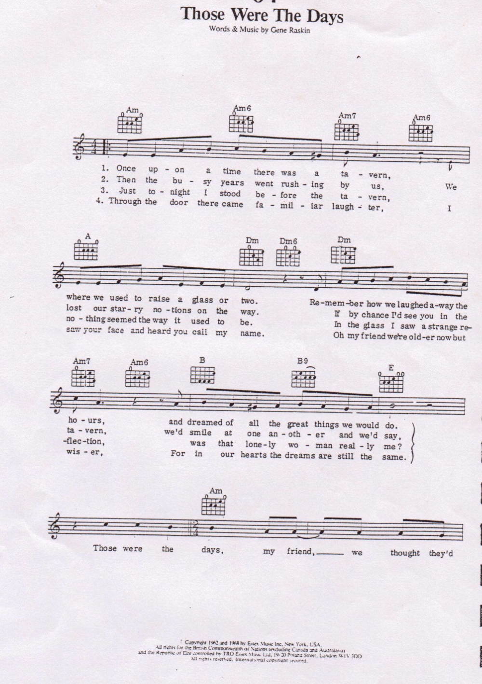
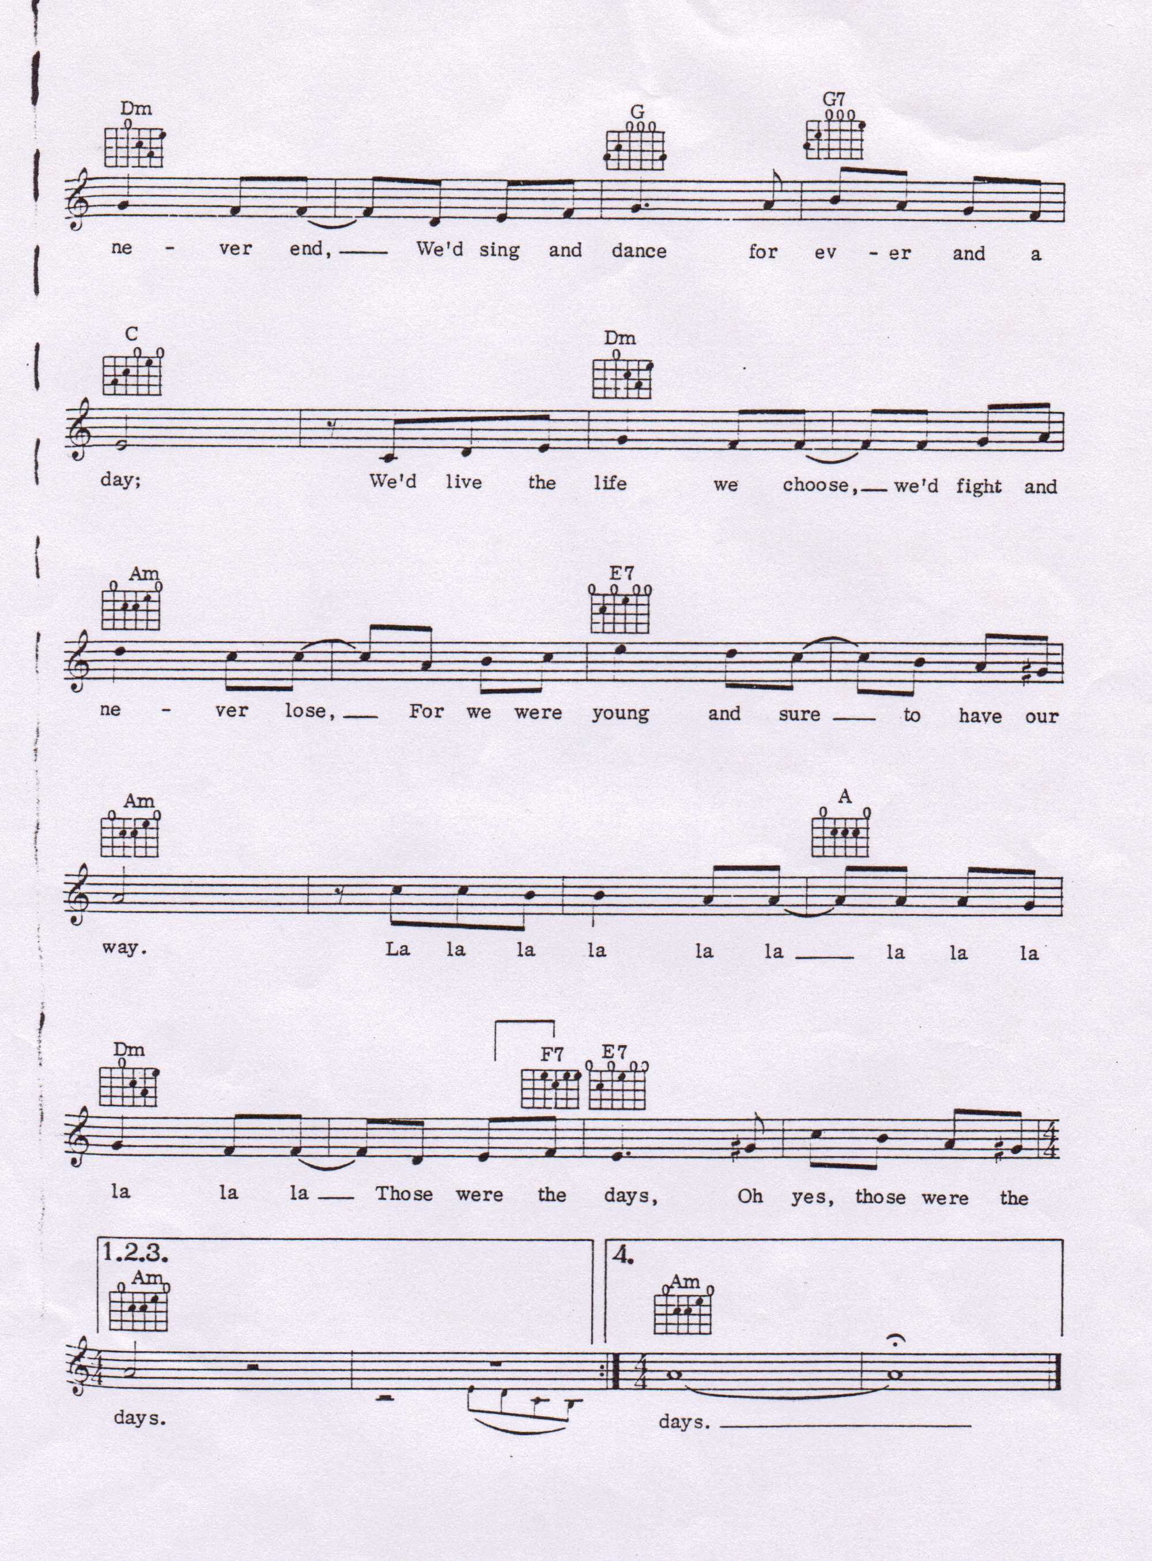

The Bible tells of Noah - Sing to the Lord, no 54

The Wise Man built his House upon the Rock - Sing to the Lord, no 55

Who built the ark

