The Journey of Life
The journey of life may be easy, may be hard
There’ll be danger on the way
With God at my side, I’ll do battle as I ride
‘Gainst the foe that would lead me astray
Chorus: Will you trust, trust, trust, in the God of heaven
And believe His every word is true
Will you sing hosanna to his majesty on high
Who cares for me and you
My burden is light and a song is in my heart
As I travel on life’s way
For God is in heaven and he’s given me his word
That by my side he’ll stay
Chorus
True wisdom, I know, is to fear and trust his love
And to answer every call
I’ll try to obey, being instructed in his way
Cheerfully, forsaking all
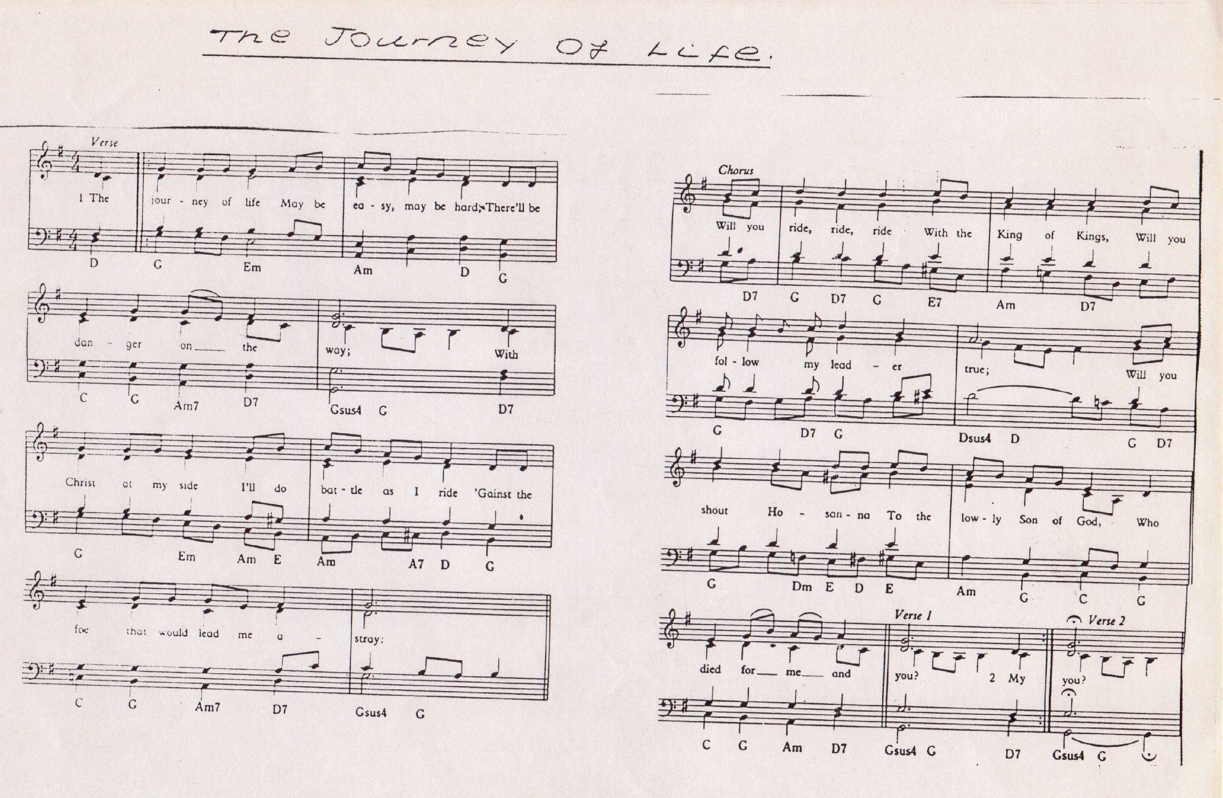
Chorus

Twinkle, twinkle, little star

Twinkle, twinkle, little star
How I wonder what you are
Up above the world so high
Like a diamond in the sky
Refrain: Twinkle, twinkle, little star
How I wonder what you are

When the blazing sun is gone
When he nothing shines upon
Then you show your little light
Twinkle, twinkle, all the night

Refrain

Then the traveller in the dark
Thanks you for your tiny spark
Could he see which way to go
If you did not twinkle so?

Refrain
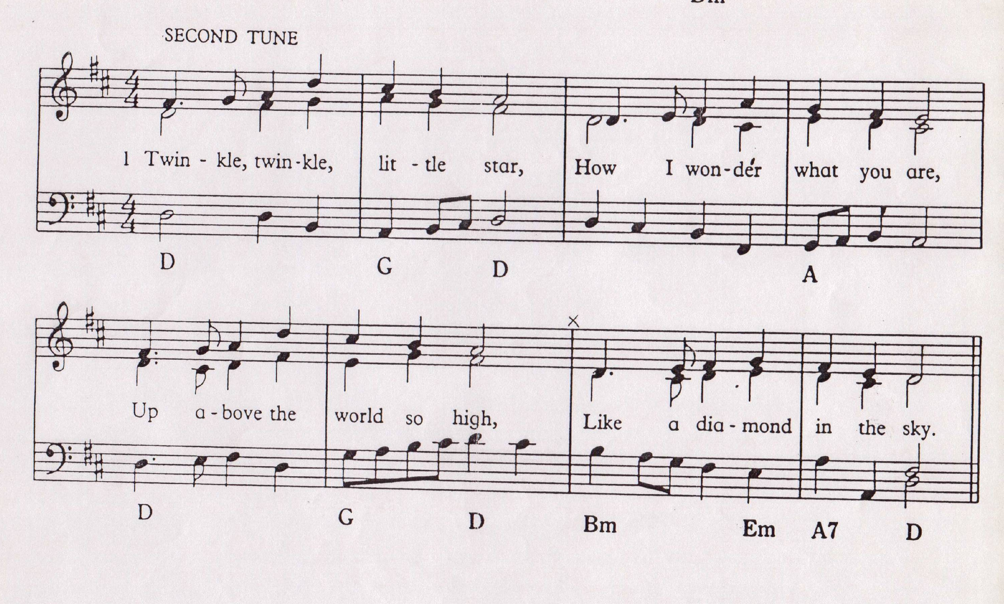

And Jonah though he’d sail away from God

To the tune of ‘The Wise man built his house upon the rock’ - Sing to the Lord, no 55

And Jonah though he’d sail away from God
And Jonah though he’d sail away from God
And Jonah though he’d sail away from God
But the anger of the Lord came down
Chorus The wind blew strong and the waves came up
The wind blew strong and the waves came up
The wind blew strong and the waves came up
And the anger of the Lord came down

The wise man learns to place his trust in God (three times)
And the answer of the Lord came down

Chorus with last line: And the answer of the Lord came down

And Jonah was wrong to disobey his God (three times)
So over the side he went

Chorus with last line: So over the side he went – SPLASH!

Morning has broken – Sing to the Lord, no 9

Take my life – Christadelphian Hymn Book, no 163

Teach me Thy way – Christadelphian Hymn Book, no 165

This is an order from the king

To the tune of ‘The animals went in two by two’

This is an order from the king, the king, the king (twice)
This is an order from the king
To this command you all must cling
Refrain: And they all went into their homes
For to remember their ways

All persons now to hold a fast, a fast, a fast (twice)
All persons now to hold a fast
Until the anger of God is past
Refrain

To wearing sackcloth you must turn, must turn, must turn (twice)
To wearing sackcloth you must turn
Repentance you will have to learn
Refrain

The king has ordered all to pray, to pray, to pray (twice)
The king has ordered all to pray
To cease from wickedness today

Refrain

O Lord we do not wish to die, to die, to die (twice)
O Lord we do not wish to die
For mercy we implore and cry

Refrain

We’ve 40 days in which to change, to change, to change (twice)
We’ve 40 days in which to change
Our lives we all must re-arrange
Refrain: And we’ll all go to our homes
And promise to change all our ways

