Esther Songs

In Shushan lives a king
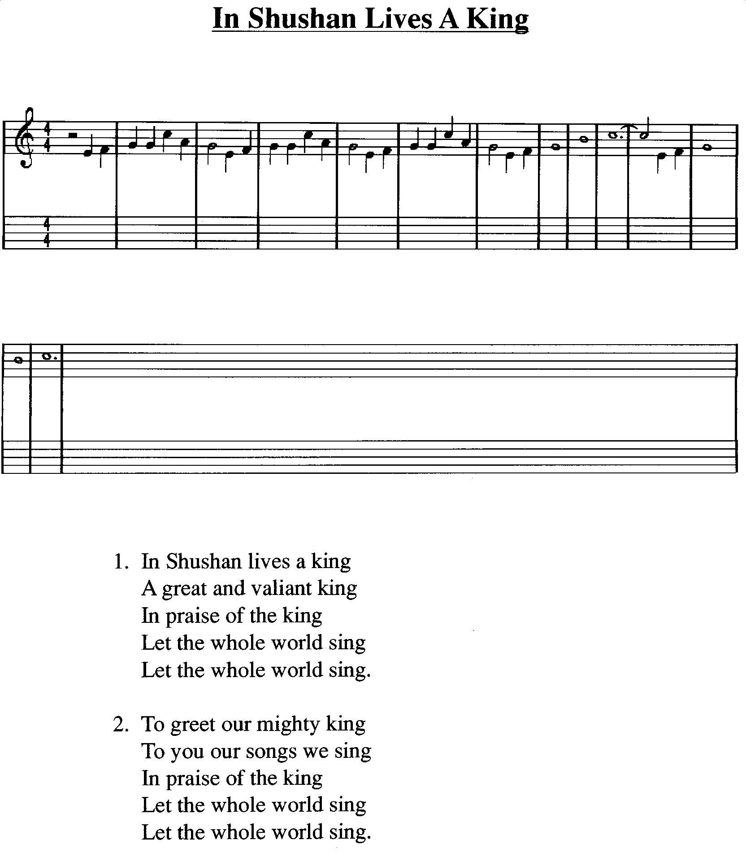

The Medo-Persian Law
The Medo-Persian law To the tune ‘The Grand Old Duke of York’
The law that can’t be changed
It must not be
It will not be
It can’t be re-arranged

By the waters of Babylon - Sing Hosanna 2, page 9

Esther, please don’t tell
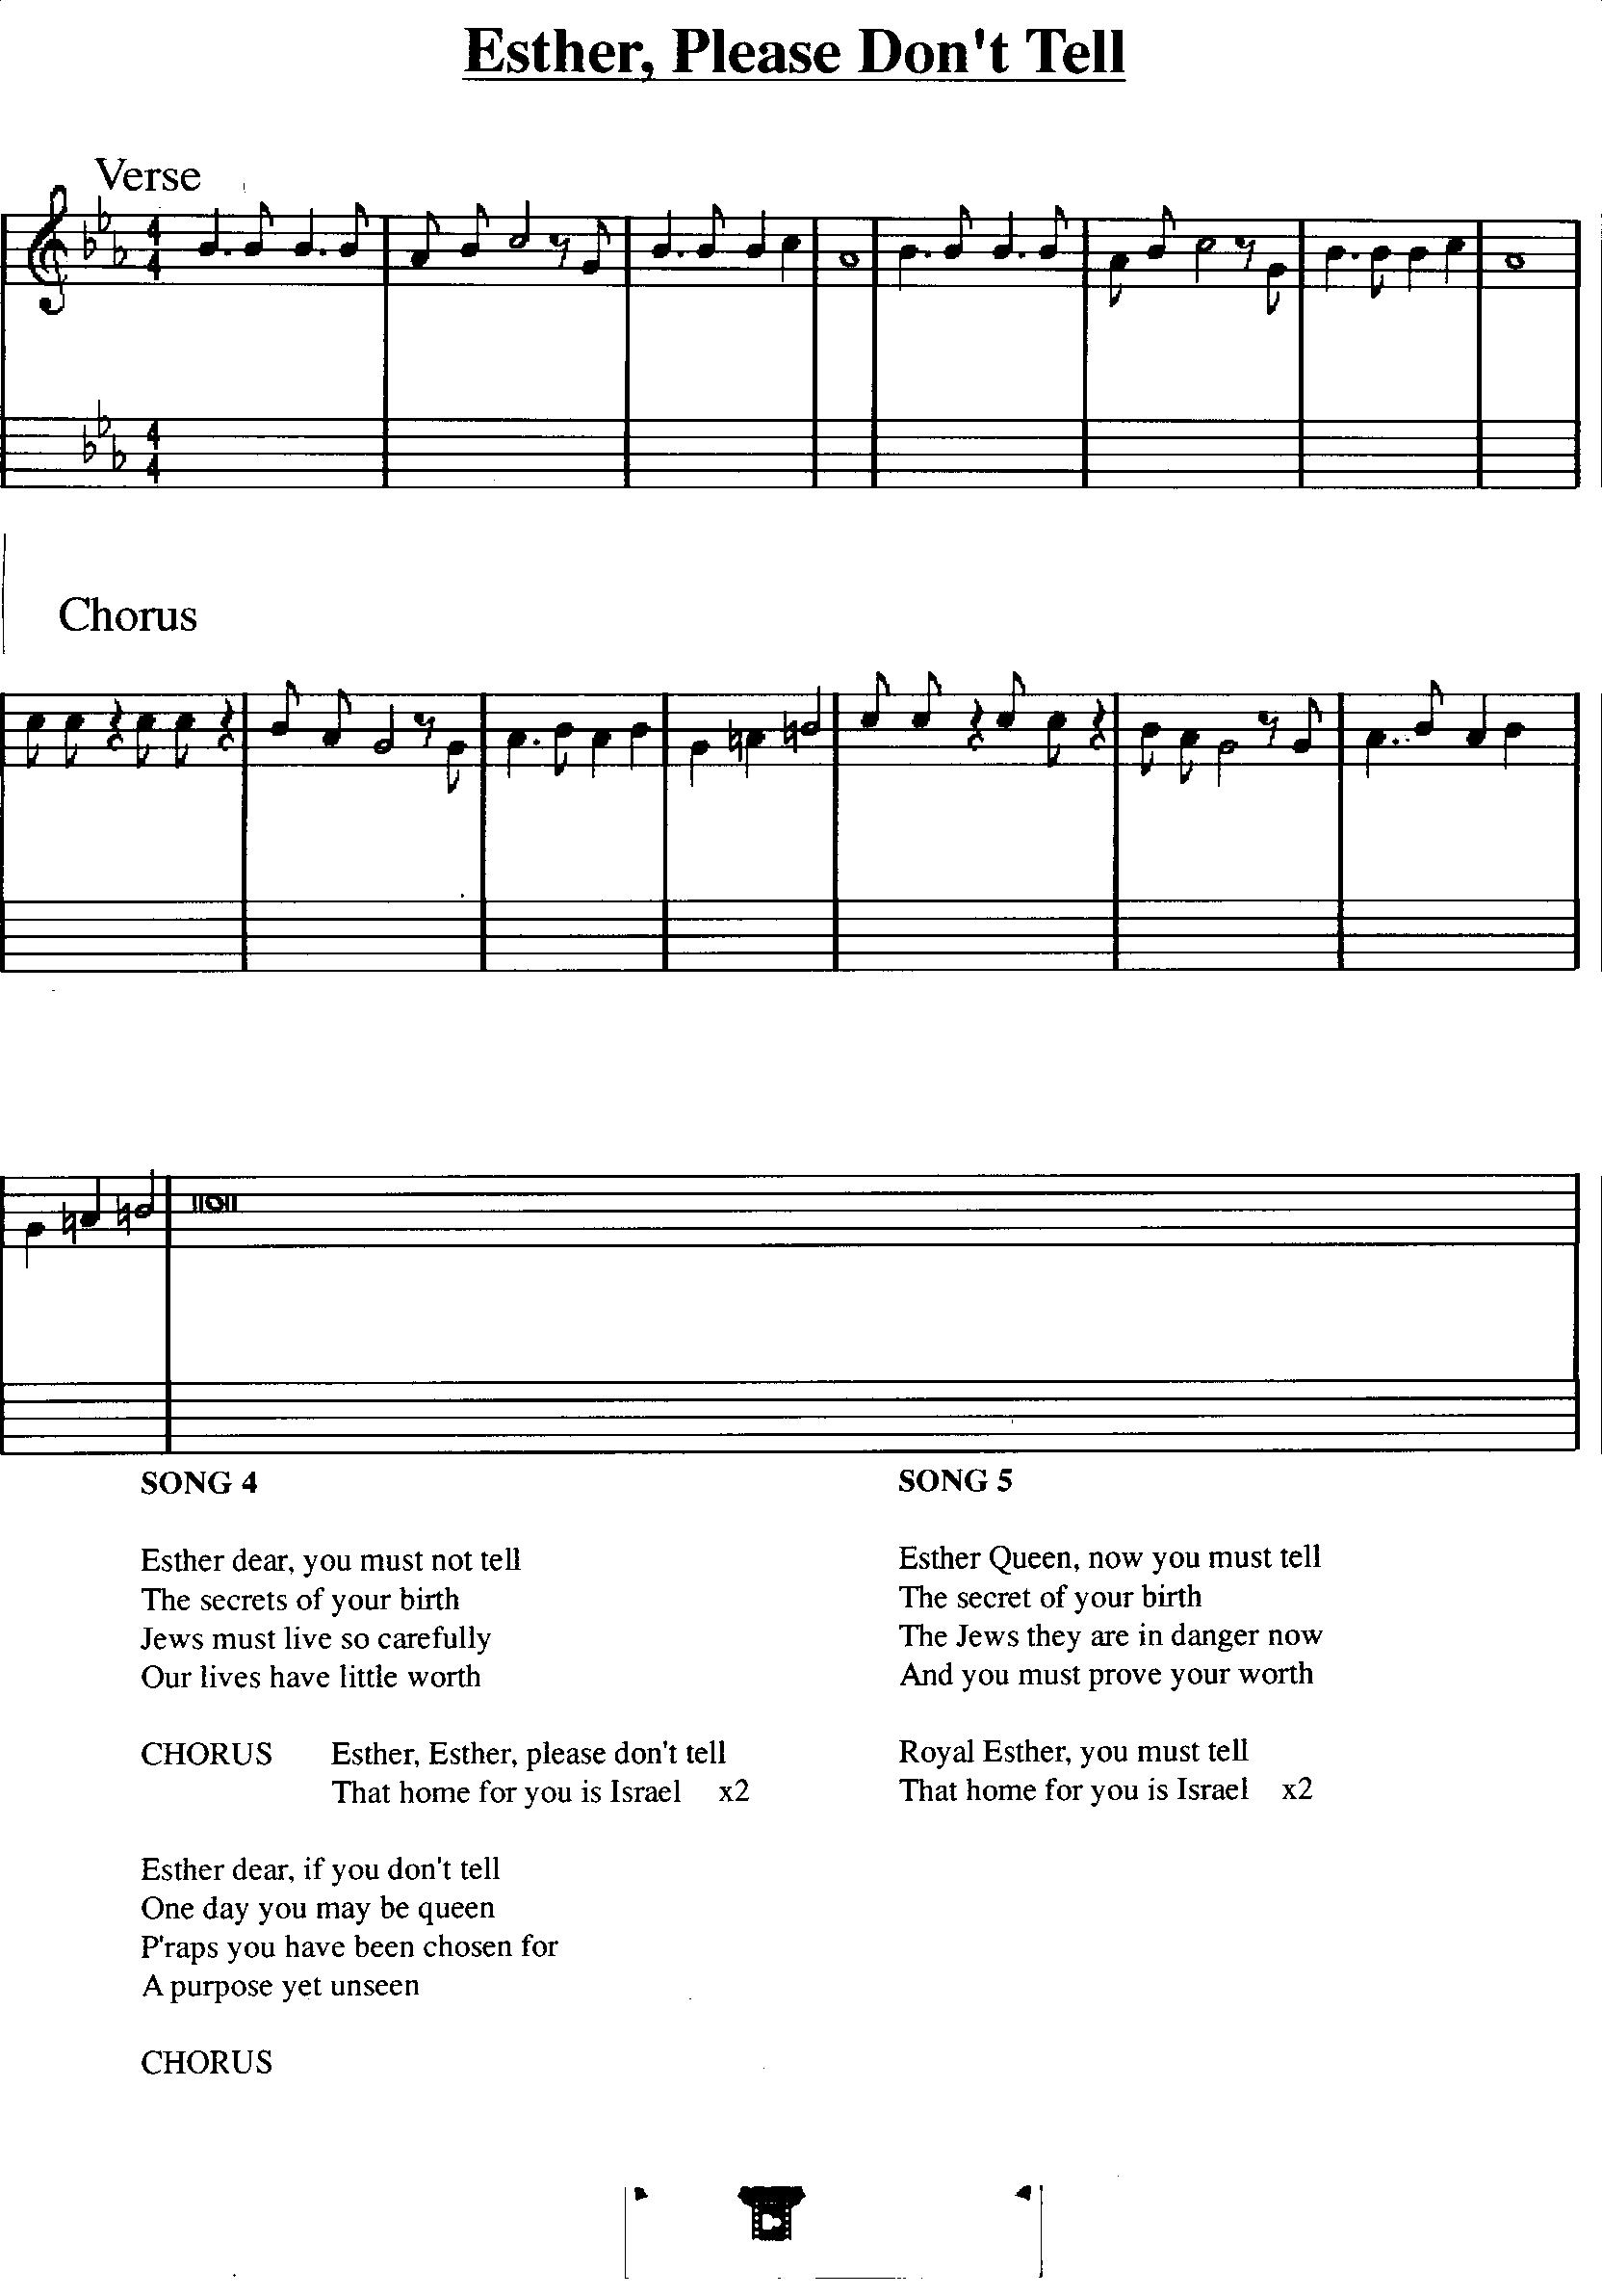

Esther, Queen, now you must tell – music as above

Blessed be the name of the Lord - Praise the Lord, no 14

